Assignment 5 – DashCop Visual Components

Alexander Gould, Joshua King, M. Littlefield, Jamie Schweibniz

The DashCop design aesthetic was based off of the minimalistic style found in most apps. A simple logo, the police cap, is easily recognizable and distinct from other apps a person may have on their phone. The layout is based around the need of the user to browse the videos they’ve taken, as well as keeping the format simple since most users will simply speak commands in order to use the app.

 DashCop App Icons

 Loading Screen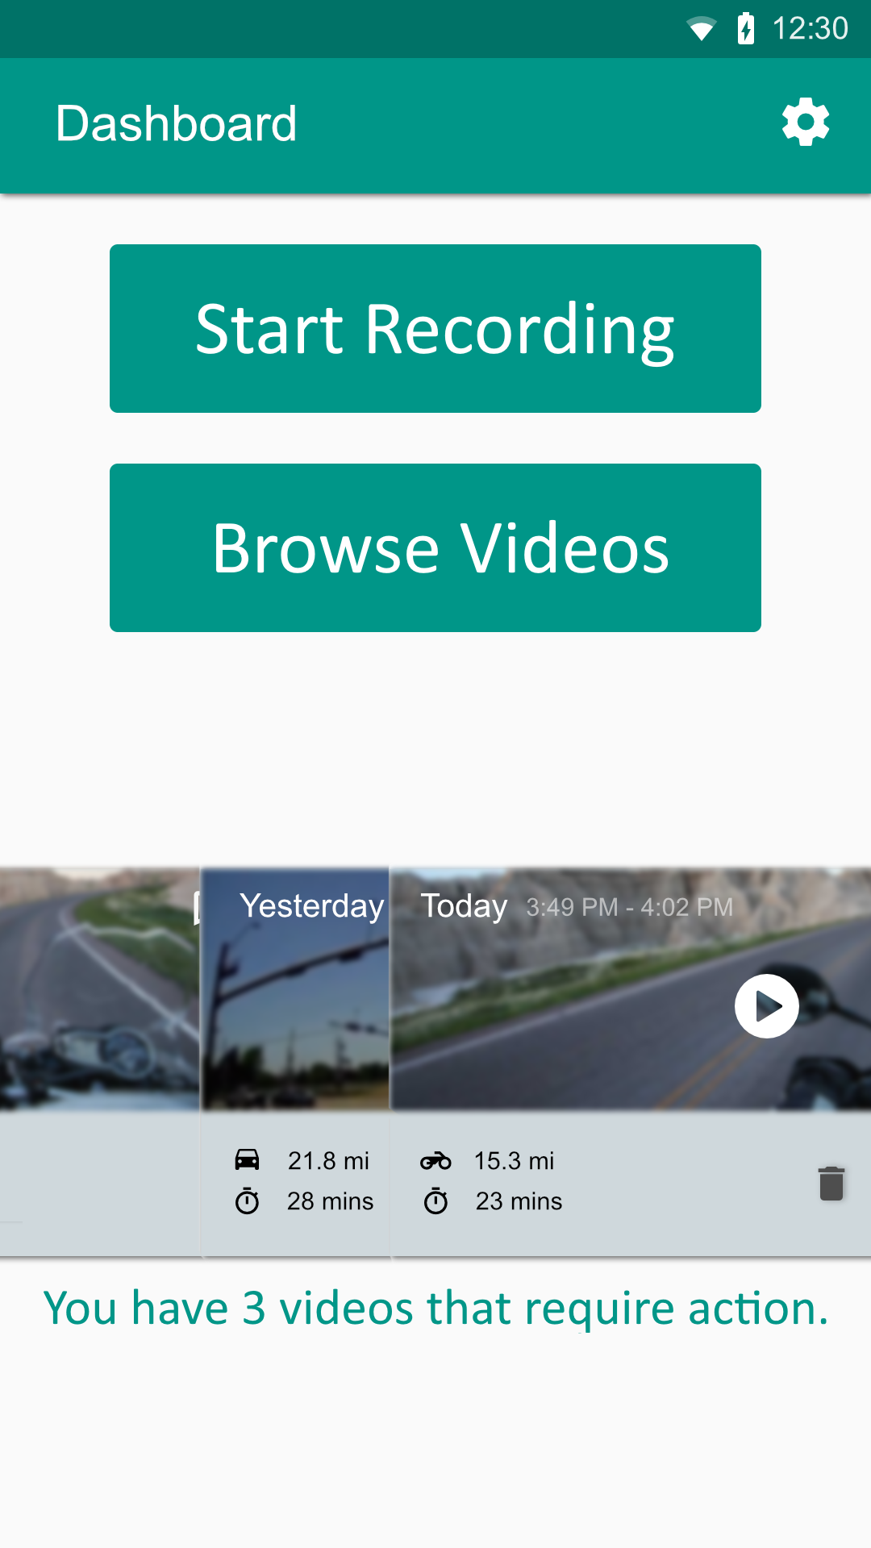 Main Page

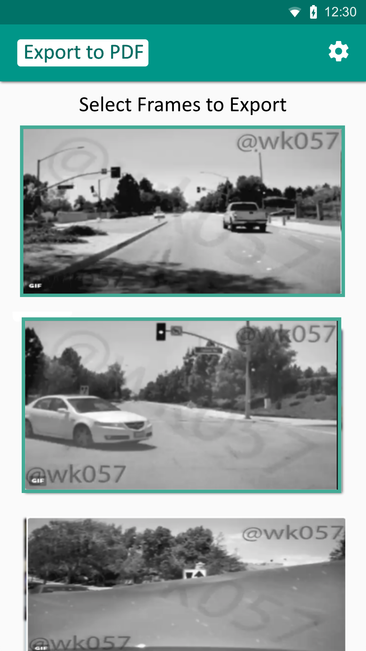 Video Export

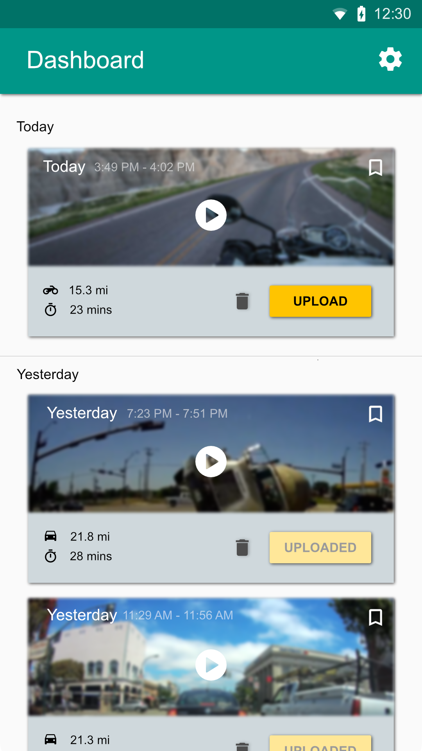 Browse Videos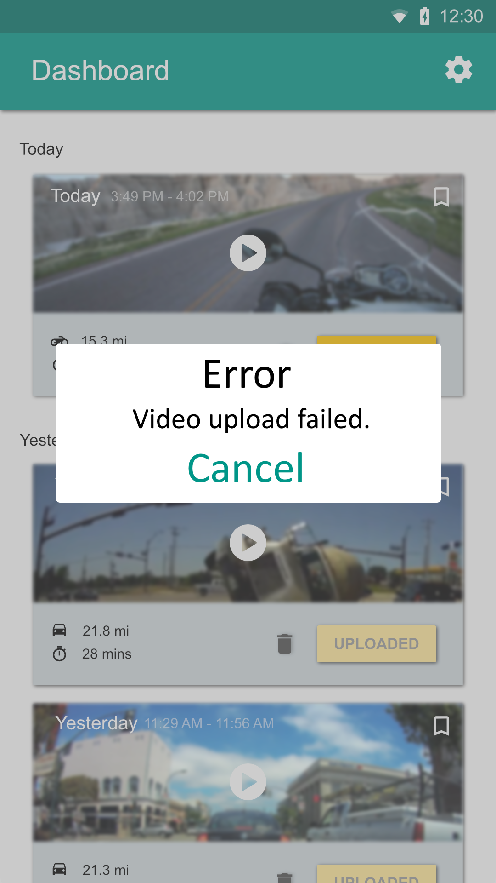 Error Screen